

PREPARATION GUIDE

This document will help you get ready for the workshop on July 18, 2024. If you are able to complete this process through step 7 for either ChemCompute (if you have an academic email address ending in .edu) or GitHub Codespaces, then you should be ready for the workshop.

The steps in this document will be the focus of the office hours on Monday, July 15, 2024. You will receive zoom information for this office hour if you registered.

If you have little or no prior coding experience with Python, you are encouraged to go through the two previous Crash Courses on Python Scripting:

1. [Python Scripting for Biochemistry & Molecular Biology Part 1](https://pdb101.rcsb.org/train/training-events/python)
2. [Python Scripting for Biochemistry & Molecular Biology Part 2](https://pdb101.rcsb.org/train/training-events/python2)

The linked pages include summaries of the contents of these two workshops.

This document contains four sections that apply to this workshop. Please click on this video to open a [19-minute video](https://rit.zoom.us/rec/share/5fAOhVtM0fPsNkvRrl0KM_o6zYWoj421rezPOX5uxE1TQ9-k8ZTBum12hCrf_4hO.YaB1NISD-d8rzl9j) that will help you through this process.

[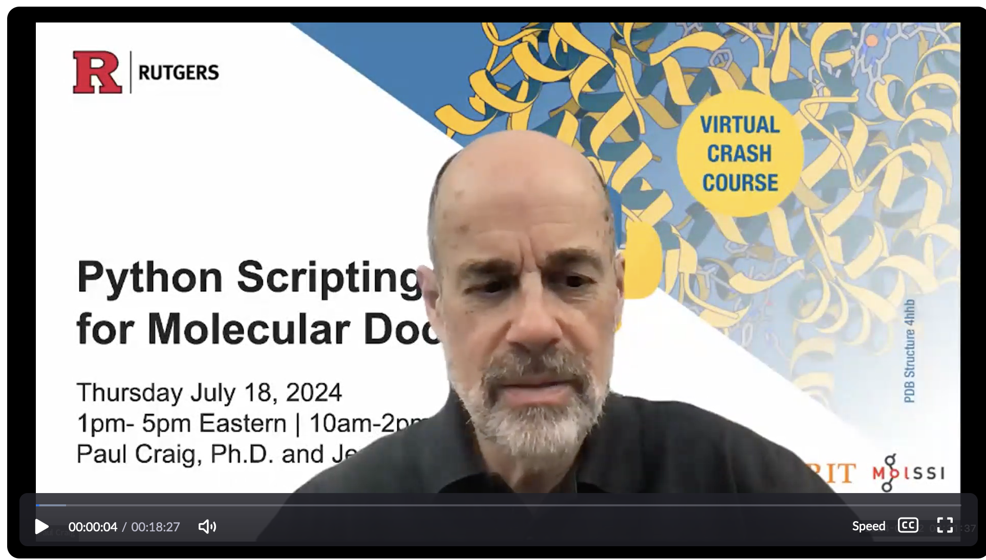](https://rit.zoom.us/rec/play/3btpdNr39YH2hsSC7--63Wh_GeByHFtzoR3-nACHlnNQkPjBhraO6Du9xLD-iUD1KPCY_6OJSx5dhQg.pjjrPq9boFF0jUMv?canPlayFromShare=true&from=share_recording_detail&continueMode=true&componentName=rec-play&originRequestUrl=https%3A%2F%2Frit.zoom.us%2Frec%2Fshare%2F5fAOhVtM0fPsNkvRrl0KM_o6zYWoj421rezPOX5uxE1TQ9-k8ZTBum12hCrf_4hO.YaB1NISD-d8rzl9j)

1. Setting up an Account at ChemCompute.org (for users with an **academic** **email** account). This section starts at 3:10 in the [video](https://rit.zoom.us/rec/share/5fAOhVtM0fPsNkvRrl0KM_o6zYWoj421rezPOX5uxE1TQ9-k8ZTBum12hCrf_4hO.YaB1NISD-d8rzl9j).
2. Starting a GitHub Codespace (for users with a corporate or other **non-academic email** account). This section starts at 9:35 in the [video](https://rit.zoom.us/rec/share/5fAOhVtM0fPsNkvRrl0KM_o6zYWoj421rezPOX5uxE1TQ9-k8ZTBum12hCrf_4hO.YaB1NISD-d8rzl9j), and again at 15:35 in the [video](https://rit.zoom.us/rec/share/5fAOhVtM0fPsNkvRrl0KM_o6zYWoj421rezPOX5uxE1TQ9-k8ZTBum12hCrf_4hO.YaB1NISD-d8rzl9j).
3. Browsers for the Crash Course (for all). This section begins at 15:00 in the [video](https://rit.zoom.us/rec/share/5fAOhVtM0fPsNkvRrl0KM_o6zYWoj421rezPOX5uxE1TQ9-k8ZTBum12hCrf_4hO.YaB1NISD-d8rzl9j).
4. Discord server for the Crash Course (for all). This section begins at 16:48 in the [video](https://rit.zoom.us/rec/share/5fAOhVtM0fPsNkvRrl0KM_o6zYWoj421rezPOX5uxE1TQ9-k8ZTBum12hCrf_4hO.YaB1NISD-d8rzl9j).

## **Setting up an Account at ChemCompute.org (Academic Users)**

If you have an **academic email ending in .edu,** please follow these instructions. If you will be using a different email type (gmail, etc.), please use the instructions below for Starting a GitHub Codespace.

1. Set up an account on Chemcompute.org
   1. Go to [Registration Link](https://chemcompute.org/register/) at Chemcompute.org. You will see this screen:  
        
      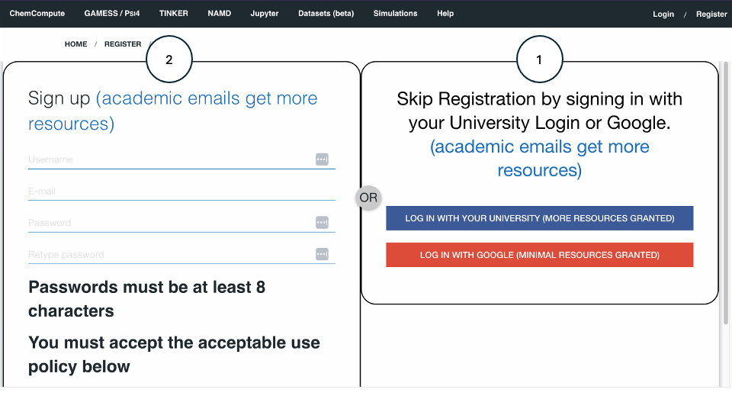
   2. Option 1 - try this first: Go to the right side of the registration page and *log in with your university* credentials, so you won’t have to remember another password; or
   3. Choice 2: Go to the left side of the registration page, create a username, enter your academic email (ending in .edu), and create a password.
2. Log into Chemcompute.org.
3. Use the Jupyter dropdown menu to select *Clone a github repo to your notebook*.  
     
     
     
   
4. This will open a new tab that looks like the above image. You have already completed step 1 on this page (Login to ChemCompute…). Click the Start notebook button on step 2 and you will come to the Server Options screen. Select Jupyter Lab (see the red arrow below).  
     
   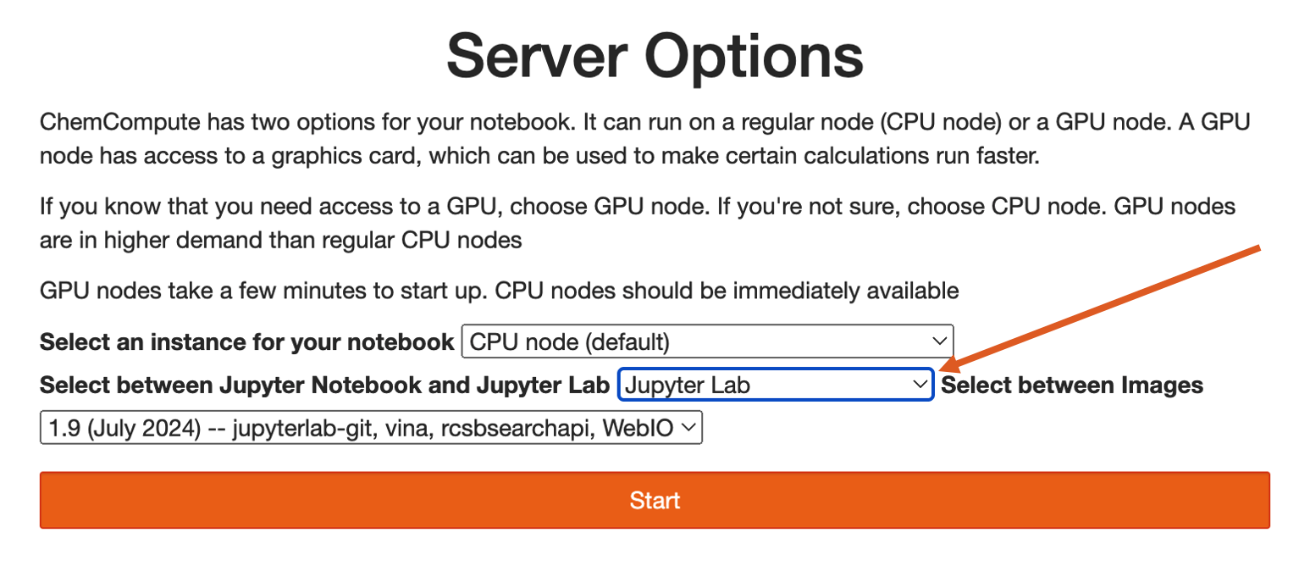  
     
   then return to this page.

The Start Notebook button will then change to Done (lab) started.  
  


1. Enter the following URL in the URL box: <https://github.com/janash/iqb-2024.git>
2. Select Jupyter Lab and click the Clone Repo button:  
     
   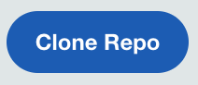  
     
   When you hit the Clone Repo button, you may see one or two error messages that you can safely ignore.   
   The first warns of an error message that is about to appear:  
     
   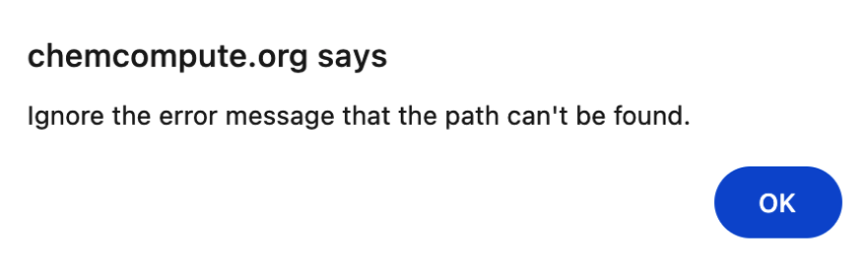  
     
   The second is the *Path Not Found* error message which you can ignore. Simply proceed to the next step.  
     
   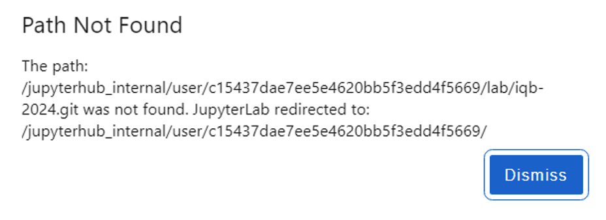
3. You should see a screen that looks similar to this one. The only difference is that my directory (shown in the red box) has some additional files. The Launcher screen will be the same for everyone.   
     
     
     
   This is where **Academic Users** need to be to start the Crash Course. To return to this space before beginning the crash course:
   1. Log into <https://chemcompute.org/>.
   2. Hover over Jupyter on the home page and select **Use Psi4 or JupyterHub**.
   3. You may see the Server Options window (see step 4 above). If so, select **Jupyter Lab** in the second drop-down menu. This will bring you to Jupyter Lab for the crash course.

## **Starting a GitHub Codespace (Non-Academic)**

Use this approach if you do not have an academic email.

1. Make a GitHub Account and sign in at <https://github.com/signup>
2. Navigate to <https://github.com/janash/iqb-2024>
3. Start GitHub Codespaces

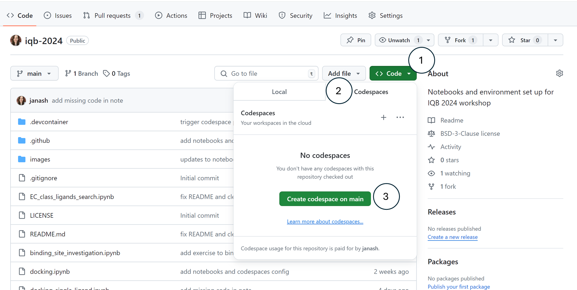

* 1. Click the white arrow next in the green “< > Code” button, marked by (1), above.
  2. After clicking the arrow a dropdown will appear. Make sure you click the right tab that says “Codespaces”, marked by (2), above.
  3. Click the green button that says “Create codespace on main”.

1. After clicking this button, a new window will open that looks like the image below. This window is a Visual Studio Code interface to the Codespace. We will not be using this interface, but we have to start it once to start the codespace. You can close this tab now.  
     
   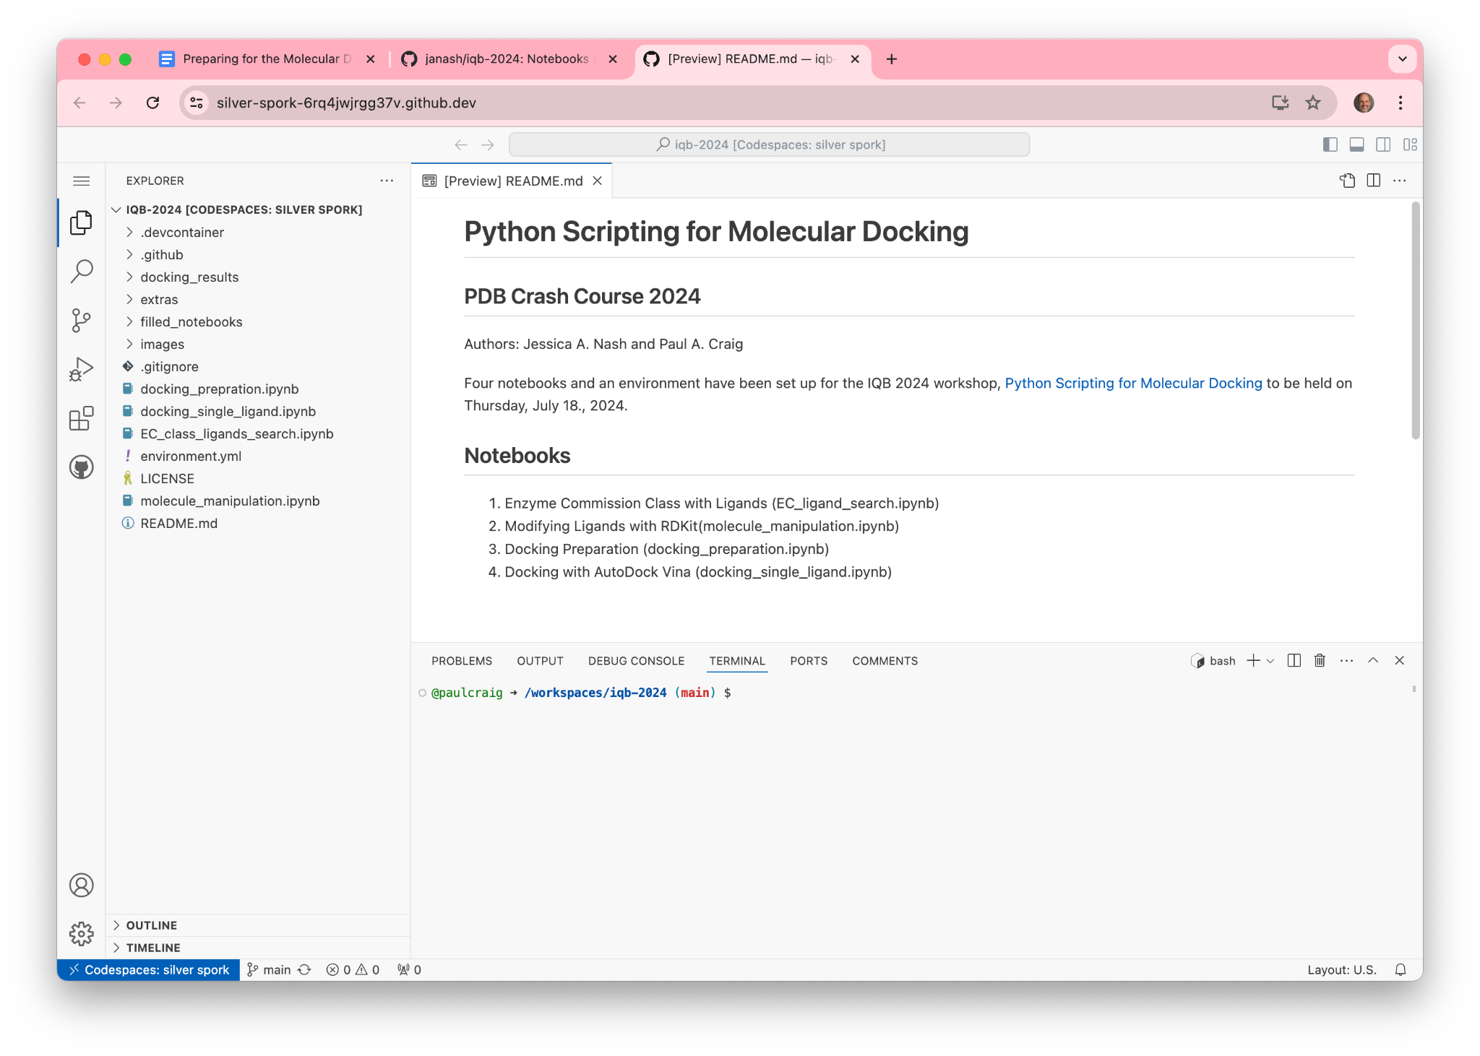
2. Click back to the tab where you have the GitHub repository open and **refresh the page**. Now bookmark this page. You will come back here on Thursday. Before moving on to step 6, you need to increase the computing power of your Codespace by following these steps for the two images below:
   1. Navigate to <https://github.com/janash/iqb-2024>.
   2. Select the Codespace tab.
   3. Click on the three dots next to the name of your codespace.
   4. Select Change machine type. This will bring up the Machine Type window.
   5. Select 4-core 16 GB RAM 32 GB.
   6. Click on Update Codespace.

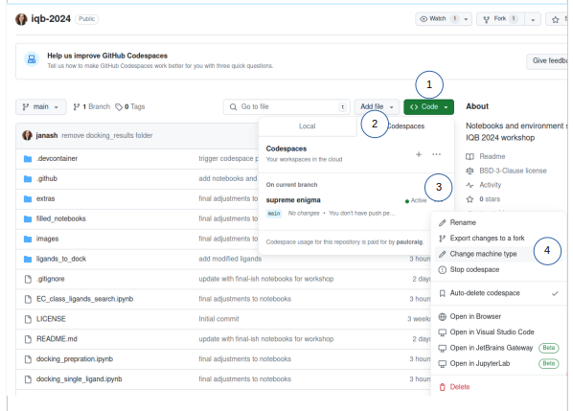  
  
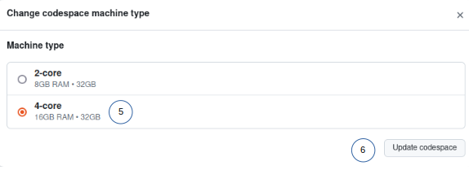

1. After refreshing the page, open the Code tab again. We are going to open our Codespace using a Jupyterlab interface.

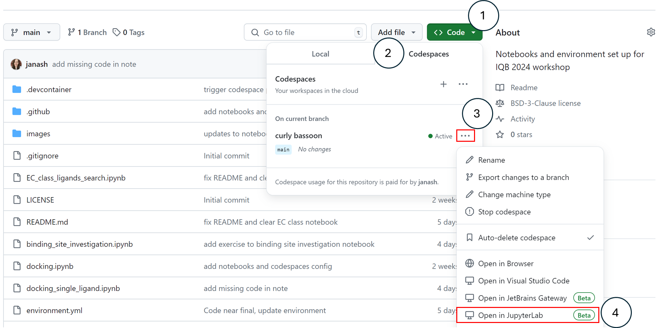

* 1. Click the white arrow next in the green “< > Code” button, marked by (1), above.
  2. After clicking the arrow a dropdown will appear. Make sure you click the right tab that says “Codespaces”, marked by (2), above.
  3. Now, instead of the green button that says “Create Codespace on main”, you will see the name of the Codespace you created in the last step. This will be a random silly name. In the example above, the name of the Codespace is “curly bassoon”. Click the three dots to the right of the Codespace button.
  4. Click “Open in JupyterLab”. A new tab with a Jupyterlab interface will open. This is the Codespace you should use for the exercises.

1. This is where **non-academic users** need to be to start the Crash Course. Before the course begins, return to <https://github.com/janash/iqb-2024> and repeat steps 6a-d to open your Codespace in Jupyter Lab.

## 

## **Browsers for the Crash Course**

You will be running the Jupyter Notebooks for this crash course from a browser on your desktop. If you can open the Jupyter notebooks in your default browser in either ChemCompute.org or GitHub Codespaces, you’re all set. If there is a problem with loading in either case, simply try a different browser. One of the crash course leaders found that Codespaces would not work in Firefox on his laptop (probably due to some settings or add-ons), so he switched to Chrome and it worked fine.

## **Discord server for the Crash Course**

We have decided to use a Discord server for questions, answers and chat for the Crash Course due to the large number of participants. To use the Discord server, you will need to install Discord on your computer, tablet or smartphone.

1. Go to <https://discord.com/>
2. Download the app on your device.
   1. For computers, the website will detect your computer type and give you the option to download.
   2. For iPhone users, go to the App Store and search for Discord, then install it.
   3. For Android users, go to Google Play, search for Discord, then install it.
3. Create a Discord account
4. Join the Discord Server for the Crash Course: <https://discord.gg/8FWCZmsh>